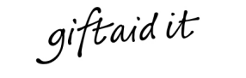
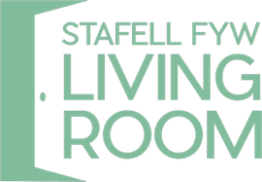
Gift Aid Declaration Form –
For past present and future donations

Name of Charity
_ _ _ _ _ _ _ _ _ _ _ _ _ _ _ _ _ _ _ _ _ _ _ _ _ _ _ _ _ _ _ _ _ _ _ _ _ _ _ _

Please treat as Gift Aid donations all qualifying gifts of money made

Today in the future

Please tick all boxes you wish to apply.

I confirm I have paid or will pay an Income Tax and /or Capital Gains Tax for each year (6 April to 5 April) that is at least equal to the amount of tax that all the charities that I donate to will reclaim on my gifts for that tax year. I understand that other taxes such as VAT and Council Tax do not qualify. I understand the charity will reclaim 25p of tax on every £1 that I give on or after 6 April 2008.

Donor’s details

Title_ _ _ _ _ First name or initial(s) _ _ _ _ _ _ _ _ _ _ _ _ _ _ _ _ _ _ _ _

Surname_ _ _ _ _ _ _ _ _ _ _ _ _ _ _ _ _ _ _ __ _ _ _ _ _ _ _ _ _ _ _ _ _ _ _ _ _ _ _

Full home address_ _ _ _ _ _ _ _ _ _ _ _ _ _ _ _ _ _ _ __ _ _ _ _ _ _ _ _ _ _ _ _ _ _ _ _ _ _ __ _ _

_ _ _ _ _ _ _ _ _ _ _ _ _ _ _ _ __ _ _ _ _ _ _ _ _ _ _ _ _ _ _ _ _ _ _ __ _ _ _

Postcode_ _ _ _ _ _ _ _ _ _ _ _ _ _ _ _

Date_ _ _ _ _ _ _ _ _ _ _ _ _ _ _ _ _ _ _ _

Signature_ _ _ _ _ _ _ _ _ _ _ _ _ _ _ _ _ _ _ _

Please notify the charity if you:
- Want to cancel this declaration
- Change your name or home address
- No longer pay sufficient tax on your income and / or capital gains

If you pay Income Tax at the higher or additional rate and want to receive the additional tax relief due to you, you must include all your Gift Aid donations on your Self Assessment tax return or ask HM Revenue and Customs to adjust your tax code.

PLEASE RETURN TO: THE LIVING ROOM, 77 RICHMOND ROAD, CARDIFF CF24 3AR

